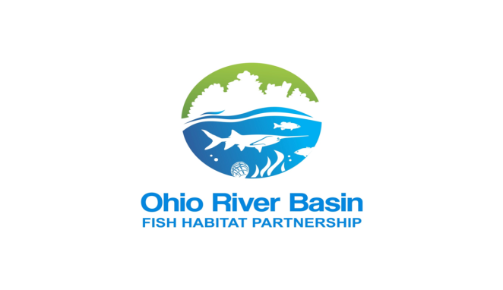
FY 2027 NATIONAL FISH HABITAT
PARTNERSHIP FUNDING OPPORTUNITY
Request for Proposals and Project Application
FY27 FUNDING AT A GLANCE
Application deadline | Oct 9, 2026, 11:59 p.m. Eastern Time
Funding request | $15,000 minimum; $100,000 maximum
Required cost share | 1:1 non-federal match required; 3:1 non-federal match encouraged
Project period | Up to two years from the start of the federal award
Submission | Email one completed Word or PDF application sent to pierce.vanvalkenburg@americanrivers.org that includes “FY27 ORBFHP RFP” somewhere in the subject line

Funding through the National Fish Habitat Partnership and U.S. Fish and Wildlife Service
www.orbfhp.com

Contents
1. Funding Opportunity 4
Funding Terms 4
Program Timeline 4
How to Apply 5
2. Partnership Mission, Geography, and Priorities 6
Mission 6
Eligible Geography 6
Strategic Priorities 7
Conservation Targets and Signature Species 8
Projects Receiving Priority Consideration 8
Guiding Principles 8
3. Eligibility and Federal Requirements 8
Eligible Applicants 8
Eligible Activities 9
Ineligible Uses of NFHP Funds 9
Environmental and Historic-Preservation Compliance 9
Monitoring, Outreach, and Data 9
4. Review and Selection 10
Threshold Eligibility - Pass/Fail 10
Scoring Framework 10
5. FY27 ORBFHP Project Application 11
6. Section 1 | Applicant and Project Information 11
Project Type 11
Project Period 11
Funding Request 12
7. Section 2 | Project Alignment 13
ORBFHP Geography and Priority Area 13
Conservation Targets and Signature Species 13
ORBFHP Strategic Priorities 13
NFHP National Conservation Priorities (NCPs) 13
Alignment with Assessment Findings and Conservation Plans 14
8. Section 3 | Project Narrative 15
9. Section 4 | Site, Readiness, and Public Benefit 17
Public Access 17
Fishing and Community Benefits 17
Project Readiness 17
10. Section 5 | Metrics and Milestones 19
11. Section 6 | Budget, Match, and Federal Readiness 21
Match Contributions 21
Federal Award Readiness 22
12. Section 7 | Required Attachments and Certification 23
Required Attachments 23
Applicant Certification 23
Submission Checklist 23

1. Funding Opportunity
The Ohio River Basin Fish Habitat Partnership (ORBFHP) is accepting proposals for FY27 National Fish Habitat Partnership (NFHP) funding to protect, restore, and enhance priority habitat for fish and mussels in the watersheds of the Ohio River Basin for the benefit of the public. Federal funding is available through NFHP and is administered by the U.S. Fish and Wildlife Service (USFWS). Funding is contingent on congressional appropriations, NFHP and Department of the Interior (DOI) review, and completion of federal award requirements. Submission to ORBFHP does not guarantee selection or funding.

Funding Terms
Award size | $15,000-$100,000 per project
Cost share | 1:1 non-federal match required; 3:1 non-federal match encouraged
Match restriction | NFHP funding must not be used as match for another federal grant. Federal funds may be identified as leveraged funding but do not satisfy the required non-federal match.
Match form | Allowable cash and/or documented in-kind contributions
Project period | Up to two years; the period begins with the executed USFWS award
Payment | Reimbursement through the U.S. Treasury's Automated Standard Application for Payment (ASAP)
Reporting | Performance and financial reporting through GrantSolutions and to ORBFHP, as required
Important: Costs incurred before execution of the federal award are pre-award costs and will not be reimbursed. Applicants should not begin work in reliance on a potential award.

Program Timeline
RFP opens | Sept 8, 2026, 9:00 a.m. Eastern Time
Informational webinar | Sept 18, 2026, 11:00-12:00 p.m. Eastern Time (register here)
Office hours with ORBFHP Coordinator | - Sept 23, 1:00 p.m. – 3:00 p.m. Eastern Time (register here)  - Sept 24, 12:00 p.m. – 2:00 p.m. Eastern Time (register here)  - Sept 25, 10:30 a.m. – 12:30 p.m. Eastern Time (register here)
Proposal deadline | Oct 9, 2026, 11:59 p.m. Eastern Time
ORBFHP review and ranking | Oct-Nov 2026
NFHP reviews proposals | Nov-Feb 2027
Department of Interior reviews proposals | March-May 2027 (subject to changes via federal review and appropriations)
Anticipated award announcements | June-Aug 2027 (subject to changes via federal review and appropriations)
Award setup | After selection, recipients complete USFWS registrations, application materials, compliance, and agreement documents

How to Apply
- Read all information listed on this application document and on https://orbfhp.com/funding/
- Attend the informational webinar on September 18, 2026, 11:00-12:00 p.m. Eastern Time (register here)
- If you have additional questions, drop into one of the virtual office hours. No appointment is required. Join at any time during one of the two-hour sessions:
  - Sept 23, 1:00 p.m. – 3:00 p.m. Eastern Time (register here)
  - Sept 24, 12:00 p.m. – 2:00 p.m. Eastern Time (register here)
  - Sept 25, 10:30 a.m. – 12:30 p.m. Eastern Time (register here)
- Complete all sections of the application included in this document. Observe the stated word limits.
- Attach the required map, photographs, budget, match documentation, and available planning, design, permit, or monitoring materials.
- Submit one complete application in Word or PDF format to pierce.vanvalkenburg@americanrivers.org that includes “FY27 ORBFHP RFP” somewhere in the subject line by the deadline. Late or materially incomplete applications will not be reviewed.
Questions: Pierce VanValkenburg, ORBFHP Coordinator | pierce.vanvalkenburg@americanrivers.org | www.orbfhp.com

2. Partnership Mission, Geography, and Priorities

Mission
The Ohio River Basin Fish Habitat Partnership (ORBFHP) focuses protection, restoration, and enhancement efforts on priority habitat for fish and mussels in the watersheds of the Ohio River Basin for the benefit of the public.

Eligible Geography
Projects must occur within ORBFHP's coordination geography: the Ohio River Sub-basin, excluding the Tennessee River and the HUC-4 Cumberland watershed. The geography includes portions of Illinois, Indiana, Kentucky, Maryland, New York, North Carolina, Ohio, Pennsylvania, Tennessee, Virginia, and West Virginia.

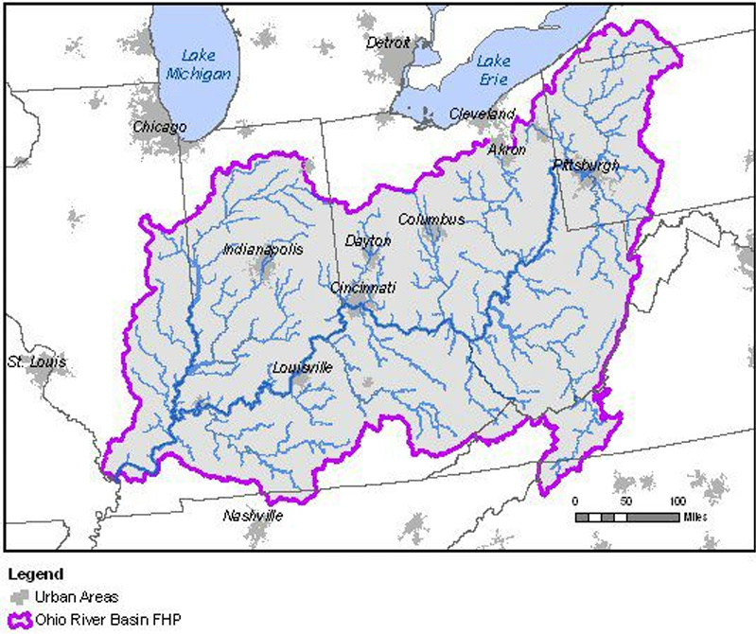

Figure 1. ORBFHP geographic boundary identified in the Strategic Plan.

Projects throughout the Ohio River Basin Fish Habitat Partnership’s eligible geography may apply. However, consistent with the ORBFHP Strategic Plan, projects in mapped priority areas receive the strongest consideration, and ORBFHP intends to direct most available project funding to priority areas. Applicants outside mapped priority areas must clearly demonstrate exceptional strategic value, habitat benefit, and alignment with an applicable state, federal, Tribal, or watershed plan.
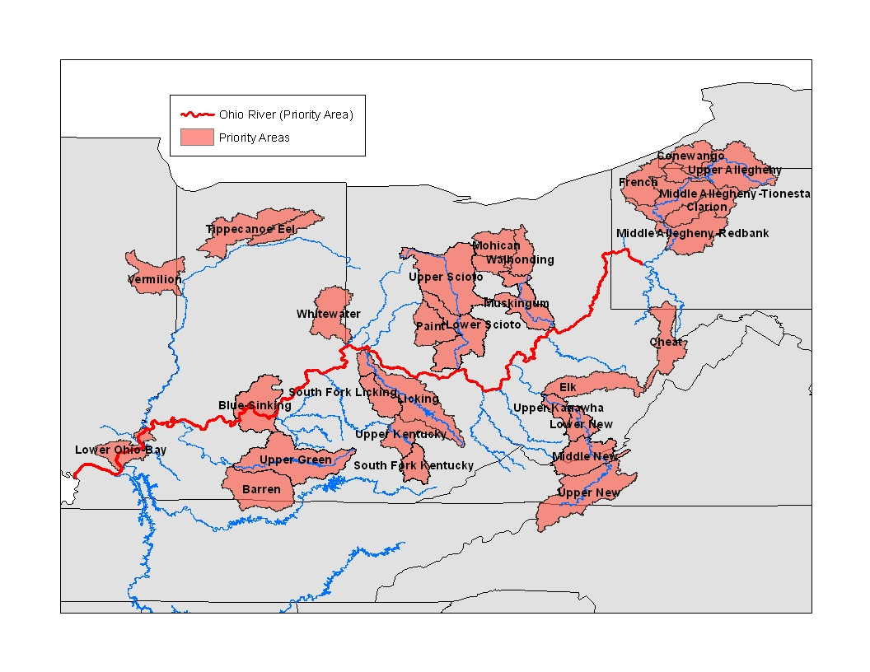
Figure 2. ORBFHP priority areas identified through the Strategic Plan.

Strategic Priorities
Competitive projects must address at least one ORBFHP strategy:
- Identify and protect intact and healthy waters.
- Restore natural variability in river and stream flows and water-surface elevations in floodplain features.
- Reconnect fragmented river, stream, reservoir, and off-river habitats to historic spawning, nursery, and rearing grounds.
- Reduce sedimentation, phosphorus, and nitrogen runoff to river, stream, and off-river habitats.
- Reduce other key pollutants or degrading conditions, including acid drainage, heavy metals, altered temperatures, or low oxygen.
- Reduce the potential for invasive-species impacts through prevention and control at the basin and priority-system scales.

Conservation Targets and Signature Species
ORBFHP prioritizes projects that improve the ecological needs of the following habitat targets and signature fish and mussel groups. Applicants should identify every target directly benefiting from the proposed work.
Conservation target | Signature species or group
Headwater and small streams | Longear sunfish; rainbow darter; orangethroat darter
Medium rivers | Smallmouth bass; spotted bass; redhorse species; logperch; tippecanoe darter
Large and great rivers | Sauger; paddlefish; sturgeon species; blue sucker
Off-channel systems | Largemouth bass; pickerel species
Native aquatic and riparian vegetation | Native plant communities supporting fish habitat and ecological processes
Native mussels | Fluvial-dependent, non-pool native mussel species

Projects Receiving Priority Consideration
ORBFHP will give greater consideration to projects that:
- Occur in a mapped ORBFHP priority area (page 7)
- Directly benefit one or more ORBFHP conservation targets or signature species present near enough to be affected by the work.
- Address root causes of habitat decline and consider watershed-scale ecological and hydrologic processes.
- Produce durable, on-the-ground habitat benefits, including broad benefits beyond the immediate project footprint.
- Reconnect substantial stream miles, floodplain, off-channel habitat, or other functionally important areas.
- Are part of a larger watershed restoration effort and align with state, federal, Tribal, local, or watershed plans.
- Use current science and appropriate design practices, avoid spreading invasive species, and account for climate resilience.
- Include measurable outcomes, practical pre- and post-project monitoring, and public dissemination of results.
- Enhance recreational, commercial, subsistence, or traditional fishing opportunities, public access, community benefits, or local economies where applicable.
- Demonstrate meaningful partner collaboration and leverage non-federal resources beyond the required minimum match.

Guiding Principles
Project selection will also reflect the ORBFHP bylaws: focus resources where important fish and mussel species and angling or species-diversity interests overlap; treat watersheds holistically; protect high-quality habitat while restoring areas where positive results are reasonably expected; use sound science and measurement; and build public support through broad local partnerships.

3. Eligibility and Federal Requirements

Eligible Applicants
Eligible lead entities may include Tribal governments and organizations, federal and state agencies, counties and local governments, nongovernmental organizations, universities, businesses, and other entities capable of receiving a federal financial-assistance award from USFWS. The lead entity must be able to meet all registration, financial-management, compliance, and reporting requirements.
Before an award can be issued: The recipient must have a Unique Entity Identifier (UEI) and active SAM.gov registration, enroll in ASAP, establish access to GrantSolutions, and complete all USFWS application and compliance requirements. Applicants are strongly encouraged to begin or confirm SAM.gov registration before applying.

Eligible Activities
Activities must directly advance fish habitat conservation and may include:
- Post-award project planning, project direction, site assessment, engineering, design, permitting support, and project oversight tied to implementation.
- On-the-ground restoration or enhancement, including earthwork, barrier removal or modification, fish passage, channel or floodplain reconnection, riparian restoration, habitat structures, vegetation, and water-quality practices.
- Materials, contracted services, and monitoring equipment directly necessary for the project; farming equipment is not eligible.
- Short-term pre- and post-project monitoring or evaluation of biological, physical, hydrologic, or water-quality response.
- Scientific assessments, research, planning, or data tools that address an ORBFHP priority data gap and have a clear pathway to conservation action.
- Outreach, education, training, and community or landowner engagement that directly advance fish habitat conservation.
- Easement-related conservation work when allowable and accompanied by an operations and maintenance plan; direct realty acquisition or rental payments are not eligible.

Ineligible Uses of NFHP Funds
- Actions required by existing federal, state, Tribal, or local regulatory programs. Voluntary actions exceeding regulatory requirements may be eligible.
- Realty costs, including purchasing or leasing interests in real property or making rental or other land-use incentive payments to landowners.
- Pre-award costs, including preliminary designs, surveys, appraisals, or other expenses incurred before the federal award is executed.
- Routine operation or maintenance of facilities, structures, or other construction.
- Habitat projects involving credits or mitigation banking.
- Lobbying activities.
- Costs not allowable, allocable, reasonable, and necessary under the federal award.

Environmental and Historic-Preservation Compliance
USFWS is responsible for final federal compliance determinations. Selected recipients must provide information and documentation needed to comply with applicable federal laws, including the National Environmental Policy Act, Endangered Species Act, National Historic Preservation Act, Clean Water Act, and Rivers and Harbors Act, as well as applicable state, local, and Tribal requirements. No ground-disturbing work may begin until the award and required reviews and permits are complete.

Monitoring, Outreach, and Data
Every funded project must include appropriate monitoring or evaluation and an outreach, education, or results-dissemination component. Monitoring may use existing state, federal, Tribal, local, academic, or partner programs. Awardees must provide project locations, metrics, photographs, reports, and other information needed for ORBFHP and NFHP project databases and public reporting.

4. Review and Selection
ORBFHP will first screen applications for threshold eligibility. Eligible proposals will be evaluated by reviewers designated through the Partnership's project-review process and forwarded to the Steering Committee for final ranking. Steering Committee members with a project conflict will be expected to recuse themselves consistent with the bylaws.

Threshold Eligibility (Pass/Fail) – Check all that Apply
☐ Submitted on time and materially complete.
☐ Located within eligible ORBFHP geography.
☐ Lead entity is capable of receiving a USFWS federal financial-assistance award.
☐ Requests $15,000-$100,000 and provides at least 1:1 non-federal match.
☐ Proposes an eligible activity and a project period of no more than two years.
☐ Addresses at least one ORBFHP strategic priority and identifies measurable fish-habitat outcomes.

Scoring Framework
Criterion | What reviewers will consider
Strategic alignment | Alignment with ORBFHP strategies and NFHP National Conservation Priorities (NCPs); location within a ORBFHP priority area geography; benefits to ORBFHP conservation targets, signature species, or Species of Greatest Conservation Need (SGCN); and support from relevant national, regional, basin-wide, state, Tribal, or watershed assessments and conservation plans.
Ecological need and benefit | Evidence of need; root causes addressed; scale, connectivity, water-quality, hydrologic, or habitat benefit; durability
Technical merit and readiness | Sound methods and design; realistic workplan; permits/compliance readiness; applicant capacity; climate and invasive-species considerations
Monitoring and measurable outcomes | Specific metrics; appropriate monitoring/evaluation; ability to document and share results
Partnership and public benefit | Collaboration; community engagement; fishing, access, economic, Tribal, or underserved-community benefits; outreach
Budget and leverage | Reasonable and cost-effective budget; match certainty; leverage beyond minimum; clear link between costs and outcomes
Selection note: ORBFHP project ranking is one step in the federal funding process. Top-ranked projects may be advanced to NFHP and USFWS for additional review. ORBFHP or USFWS may request revisions, additional documentation, a reduced award amount, or other conditions before an award is issued.

FY27 ORBFHP PROJECT APPLICATION
Complete every applicable field. Enter N/A where a question does not apply.

Section 1 | Applicant and Project Information
Project title
________________________________________________________________________________
Lead entity
________________________________________________________________________________
Entity type (Tribal / federal / state / county-local / NGO / university / business / other)
________________________________________________________________________________
Project lead: name, title, email, phone, mailing address
________________________________________________________________________________
Project partner or co-officer: name, affiliation, email, phone
________________________________________________________________________________
Watershed and waterbody
________________________________________________________________________________
County and state
________________________________________________________________________________
12-digit HUC(s)
________________________________________________________________________________
Latitude and longitude (decimal degrees, NAD83)
________________________________________________________________________________
Congressional district(s)
________________________________________________________________________________
State or federal fish-management contact: agency, name, email, phone
________________________________________________________________________________

Project Type - Check All That Apply
☐ Engineering assessment
☐ Design
☐ Construction
☐ On-the-ground implementation
☐ Monitoring or evaluation
☐ Scientific assessment, research, or data tool
☐ Education, outreach, or communication
☐ Easement-related conservation work
☐ Other: ________________________________

Project Period
Proposed start month/year:
________________________________________________________________________________
Proposed end month/year (must be within two years of the executed federal award):
________________________________________________________________________________

Funding Request
ORBFHP/NFHP funds requested | $
Non-federal cash match | $
Non-federal in-kind match | $
Other leveraged federal funds (not match) | $
Total project cost | $
Will you accept partial funding? | ☐ Yes ☐ No

Certification: The required match is non-federal, is not committed as match to another federal award, and will be available during the project period.

Section 2 | Project Alignment

ORBFHP Geography and Priority Area - Check All That Apply
☐ Project is within ORBFHP's eligible Ohio River Basin geography.
☐ Project is within a mapped ORBFHP priority area (page 7). Name: ________________________________
☐ Project is outside a mapped priority area but aligns with another recognized conservation priority.
Explain the project's geographic priority and cite the applicable ORBFHP, state, federal, Tribal, local, or watershed plan. (250 words)

Conservation Targets and Signature Species - Check All That Apply
☐ Headwater/small streams - longear sunfish, rainbow darter, orangethroat darter
☐ Medium rivers - smallmouth bass, spotted bass, redhorse species, logperch, tippecanoe darter
☐ Large/great rivers - sauger, paddlefish, sturgeon species, blue sucker
☐ Off-channel systems - largemouth bass, pickerel species
☐ Native aquatic and riparian vegetation
☐ Fluvial-dependent, non-pool native mussels
☐ Other directly benefiting native species or guild: ________________________________
Describe the presence of selected species or habitat targets and how the project will directly benefit them. (300 words)

ORBFHP Strategic Priorities - Check All That Apply
☐ Identify and protect intact and healthy waters.
☐ Restore natural variability in river and stream flows or floodplain water levels.
☐ Reconnect fragmented river, stream, or off-river habitat.
☐ Reduce sedimentation, phosphorus, or nitrogen runoff.
☐ Reduce acid drainage, heavy metals, altered temperatures, low oxygen, or other degrading conditions.
☐ Prevent or control invasive-species impacts.

NFHP National Conservation Priorities (NCPs) - Check All That Apply
☐ Protect and maintain intact and healthy aquatic systems.
☐ Conserve hydrologic conditions for fish.
☐ Restore physical and living habitat supporting viable populations in impacted or at-risk systems.
☐ Reconnect fragmented fish habitat.
☐ Conserve or restore water quality for fish.
☐ Enhance recreational, commercial, subsistence, or traditional fishing opportunities.
Explain how the project addresses the selected ORBFHP Strategic Priorities and the NFHP National Conservation Priorities (NCPs). (500 words)

Alignment with Assessment Findings and Conservation Plans
Identify findings or priorities from any national, regional, basin-wide, state, Tribal, or watershed assessment, plan, or conservation strategy that demonstrate the need for the project. These may include State Wildlife Action Plans, recovery plans, Tribal plans, watershed plans, climate plans, and fishery plans, assessments, or data collections. Include the name of each assessment or plan and a link or citation when available. Indicate whether the project benefits any Species of Greatest Conservation Need (SGCN), federally or state-listed species, or species identified in another recognized conservation plan. Identify each species and the associated plan. (500 words)

Section 3 | Project Narrative
Project abstract (4,000 characters; plain-language summary suitable for public databases)

Statement of need and purpose (750 words; include evidence and the consequence of no action)

Specific, measurable project objectives (500 words)

Biological and ecological benefits (300 words)

Activities, methods, and approach (500 words; identify deliverables and current science/design standards)

Root causes addressed and watershed-scale context (300 words)

Monitoring and evaluation plan (350 words; what will be measured, how, when, and by whom, and how results will be documented and shared)

Outreach, education, and results dissemination (300 words)

Climate resilience and invasive-species considerations (250 words)

Section 4 | Site, Readiness, and Public Benefit
Current land ownership, land use, landowner support, and site control (300 words)

Public Access – Check All That Apply
☐ Creates new or increased public access
☐ Maintains current public access
☐ Provides intermittent or occasional access
☐ Does not provide public access
☐ Unknown
☐ Not applicable
Describe the public interest and why this is a strong investment of conservation funds. (250 words)

Fishing and Community Benefits – Check All That Apply
☐ Directly benefits recreational or Tribal fishing
☐ Indirectly benefits recreational or Tribal fishing
☐ Maintains current fishing benefits
☐ No clear fishing benefit
☐ Unknown
☐ Not applicable
Describe fishing, community, economic, public-access, rural, underserved-community, or Tribal benefits, as applicable. (300 words)

Project Readiness
Design status and expected completion date:
________________________________________________________________________________
Required permits and current status:
________________________________________________________________________________
NEPA review status, if known:
________________________________________________________________________________
Federal or state threatened/endangered-species review status:
________________________________________________________________________________
Historic/cultural review status:
________________________________________________________________________________
Identify readiness risks, dependencies, and the plan to resolve them within the proposed project period. (300 words)

Project protection, operations and maintenance responsibility, and expected life expectancy (250 words)

Applicant qualifications and partner roles (400 words)

ORBFHP partnership role (200 words; describe useful technical assistance, coordination, communications, or network support)

Section 5 | Metrics and Milestones
Enter the most relevant expected outcomes. Leave non-applicable rows blank. Use acres, miles, counts, cubic feet per second, or years as indicated.
Metric | Expected value | Method/source
Area of habitat protected (acres)
Area of habitat restored or enhanced (acres)
Area of habitat reconnected (acres)
Length of habitat protected (miles)
Length of habitat restored or enhanced (miles)
Length of habitat reconnected (miles)
Length/area treated for water quality or pollution
Number of barriers removed or upgraded
Number of structures modified or installed
Number of designs developed
Number of habitat or hydrologic assessments
Number of fish species/populations benefiting
Number of invasive species controlled or prevented
Area/length treated for invasive species
Area/length of native vegetation planted
Monitoring period (years)
Number of public access points or fishing opportunities
Number of partners contributing
Number of outreach/education events
Number of people or communities reached
Other project-specific outcome
Explain the expected outcomes and how the selected metrics connect to project objectives. (400 words)

Milestones and timetable (Use month/year; include design, compliance, construction/implementation, monitoring, outreach, and reporting)

Section 6 | Budget, Match, and Federal Readiness
Provide a detailed budget and justification. The final federal application and budget must be consistent with the amounts presented here. Use SF-424A for non-construction or SF-424C for construction when requested by USFWS.
Budget category | ORBFHP/NFHP funds | Non-federal match | Total
Personnel | $ | $ | $
Fringe benefits | $ | $ | $
Travel | $ | $ | $
Equipment | $ | $ | $
Supplies | $ | $ | $
Contractual / construction / engineering | $ | $ | $
Other | $ | $ | $
Indirect costs | $ | $ | $
TOTAL | $ | $ | $
Budget justification (Describe calculations, purpose, cost reasonableness, and relationship to deliverables for each category)

Indirect-cost basis (Identify the federally negotiated rate or other allowable federal basis used)

Match Contributions
Contributor | Type | Cash | In-kind | Secured? | Purpose/source
Match must be non-federal. Identify federal contributions separately as leveraged funding. ORBFHP or USFWS may request commitment letters or supporting valuation documentation before award.

Federal Award Readiness
☐ Lead entity has a Unique Entity Identifier (UEI): ☐ Yes ☐ No ☐ In process
☐ SAM.gov registration is active: ☐ Yes ☐ No ☐ In process
☐ Entity is enrolled in ASAP: ☐ Yes ☐ No ☐ In process
☐ Entity has GrantSolutions access: ☐ Yes ☐ No ☐ In process
☐ Entity has previously received federal funding: ☐ Yes ☐ No
☐ Entity was required to complete a Single Audit for the last fiscal year: ☐ Yes ☐ No ☐ Not applicable
List other federal funding supporting this project and explain how costs and match will remain separate. (250 words)

Section 7 | Required Attachments and Certification

Required Attachments – Check That You’ve Attached All Items Below
☐ Project-area map showing project location, scope, watershed context, and coordinates.
☐ At least two current project-site photographs with captions, date, photographer, and organization.
☐ Detailed budget and budget justification; SF-424A or SF-424C if requested.
☐ Available planning documents, designs, scopes of work, permits, monitoring plans, or supporting technical information.
☐ Documentation of landowner support or site control, when applicable.
☐ Letters documenting significant match or partner commitments, if available.

Applicant Certification
By signing below, the applicant certifies that the information provided is accurate to the best of their knowledge; the proposed costs are necessary for the project; required match is non-federal and is not committed to another federal award; the applicant understands that selection by ORBFHP does not constitute a federal award; and no reimbursable work will begin before execution of the USFWS award and completion of required compliance.
Authorized representative name and title
________________________________________________________________________________
Signature
________________________________________________________________________________
Date
________________________________________________________________________________

Submission Checklist:
☐ All application sections completed or marked N/A.
☐ Funding request is between $15,000 and $100,000.
☐ At least 1:1 non-federal match documented.
☐ Project period is no longer than two years.
☐ Map, photographs, budget, and available supporting documents attached.
☐ Application submitted by the stated deadline.

Submit to: pierce.vanvalkenburg@americanrivers.org by Oct 9, 11:59 p.m. Eastern Time. Retain a complete copy for your records.

